**Standard Operating Procedure**

**Drilling and Blasting**



**ODISHA MINING CORPORATION LTD.**

**KODINGAMALI BAUXITE MINE**

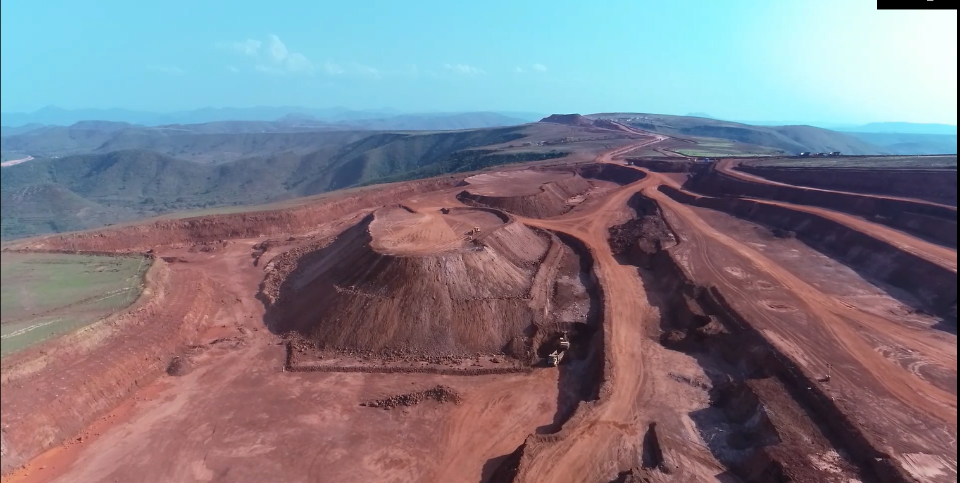

**Authorized By**

1. **PURPOSE:**

To provide the Standard Operating Procedure for Drilling and Blasting operation in Kodingamali Bauxite Mine.

1. **SCOPE:**

This procedure is applicable for safe Drilling and blasting operation in Kodingamali Bauxite Mine.

1. **RESPONSIBILITY:**

|  |  |  |
| --- | --- | --- |
|  | Drilling operation and Blasting Operation | Blaster along Drill Operator & helpers |
|  | Drill Maintenance | Maintenance In-charge |
|  | Field Operation | Foreman / Blaster |
|  | Operational Control | Manager / Asst. Manager |

1. **SAFETY AND HEALTH HAZARDS:**

**Hazards presented by, materials used in the process:-**

* Precaution against dust (Regulation 124 (6) a & b, (i) & (ii) Fire hazards,
* Precaution against fly rocks.
* Precaution against miss fire.

In order to avoid injuries to personal and damage to machinery, the following precautions are very important.

* Work required PPE i.e. with safety shoes, helmet, dust musk, fluorescent jacket suitable for long distance visibility etc.
* Adherence to Mines Pits instruction related to Operating safety as per regulation 106(20 b off MMR 1961 and DGMS guide lines & other related regulation, rules, act and MMR 1961.
* Inhaling of blast fumes / dust.
* Handling of explosives with bare hand.

***Note: Report immediately to Supervisor, Shift Incharge and Safety officer for any incident/accident.***

1. **ENVIRONMENT ASPECT:**

Regularly checking the water level in tank for wet drilling.

* Dust generation
* Noise Pollution
* Vibration

1. **TOOLS:**

N.A.

1. **PROCEDURE;**
   1. **GENERAL PRECAUTIONS:**

* Operations connected with Drilling, Charging, Stemming and blasting of deep holes shall be places un overall charge of an Asst, manager, holding at least a second class managers certificates of competency granted under Metalliferous Mines Regulations, 1961, who shall supervise the said operations in accordance with the guide lines and directives issued by the Manager.
* Notwithstanding anything contained in the Metalliferous Mines Regulations, 1961 preparation of charges, charging and stemming of holes shall be carried out under the personal supervision of a Blaster/Mine foreman, who shall fire the shots in deep holes himself.
* A proper record for every blast, showing blasting parameters like hole size, spacing burden depth of holes number of holes fired in the found charge hole charge delay and total charge of explosives fired in the round with a rough sketch showing the drilling and firing pattern shall be kept maintained in the bound paged register kept for the purpose.
* Lives of persons and property not belonging to the management against injury and damages resulting out of blasting or operations being carried on in the mines shall be adequately identified, Should there be any controversy in this regard, decision of the DGMS shall be final and binding.
  1. **DRILLING OF DEEP HOLES:**
* The area where drilling is to be done shall be thoroughly cleaned of loose rocks and debris and position of every deep hole to be drilled shall be distinctly marked by the blasting foreman, so as to be readily seen by the drillers.
* No drilling shall be commenced in an area where shots have been fired, until the blaster blasting foreman has made a thorough examination of all places including remaining butts of old deep holes, for unexploded charges that the drill rod may strike.
* No drill or bore rod or pick shall be inserted in butts of old deep holes even if an examination has failed to reveal presence of explosives.
* Drilling and charging of deep holes shall not be carried out in the same area at the same time.
* Drilling operations shall not be carried on simultaneously on two benches at places directly on above the other.
  1. **DUTIES OF DRILL OPERATORS:**

**1.** At the beginning of his shift, the drill operator shall examine the drilling equipment and satisfy himself that-

* Crown blocks are mounted securely
* Where compressed air drills are used, all hose connections are in order,
* The drilling equipment is in safe working condition, and
* Wet drilling system is in order.

**2. The drill operator shall ensure that:**

* Work persons keep clear of auger and drill stem while the drill is in motion,
* Work persons do not work under suspended tools, when tools are removes from the holes.
* All finished drill holes are properly plugged so as avoid possible injury to any one accidentally stepping onto the hole.
  1. **CHARGING OF DEEP HOLES:**
* General precautions and rules regarding handling of explosives shall be observed by the blasting crew. Only such minimum number of person shall be allowed to remain at the charging site as are required during charging operations and firing of shot holes.
* The entire area where charging of explosives is to be done shall be demarcated by suitable flags and effectively guarded to prevent unauthorized entry of persons or plying of other vehicles and shall be kept free from dry vegetation and other combustible material.
* Smoking naked light or open flames shall not be allowed within 300m of the area where charging of explosives is being carried on.
* The holes shall be charged (and fired) as soon as possible after the explosive is transported to the site of blasting, All normal precautions for charging) and firing) as laid down in the Metalliferous Mines Regulations, 1961 shall be strictly observed.
* Explosives cartridges shall not be slit or deformed adequate amount of cap sensitive explosive shall be used with non cap sensitive explosive charge to ensure complete detonation of the explosive charge.
* Explosive shall be delivered/charges the hole farthest from the priming station.
* Not more than on hole shall be in process of being charged on any face at any point of time.
* All operations connected with charging, stemming and making connections shall be done while standing on the solid ground,
* The cartridges of explosives shall be lowered carefully into the shot holes shot to avoid sticking of cartridges in the shot holes there by causing air spaces in the explosive column. After charging such hole with explosives the length of the uncharged/remaining portion of the hole shall be measured to confirm that the cartridges are in close contact with each other and there is not air grip between the explosive columns. In case the length of uncharged portion of the hole is not as per calculation, thereby indication the presence of air space, attempt may be made to push down the charge in case of slurry explosives only. The remaining holes shall then be stemmed with moist and before blasting the shot holes.
* Explosive charge shall not be allowed to sleep over in holes unless express permission in waiting to the effect is obtained.
  1. **PRECAUTIONS DURING BLASTING FROM CONCERNED AUTHORITY / FIRING:**
* Shots shall not be fired except during the hours of day light. All holes charged on any one day shall be fired on the same day.
* Shots shall not be fired in crushed, broken or fractured ground.
* As far as practicable deep holes shall be fired either between the shifts or during the rest interval or at the end of work for the day.
* The danger zone shall be distinctly demarcated (by means of red flags or other suitable means) at least 30 minutes before firing of holes.
* Proper and distinct warning by the siren installed for the purpose shall be given within the danger zone at least 10 minutes before the holes are fired.
* Before the holes are charged stemmed and fired the shot fired / blasting foreman with assistance of his assistants appointed in sufficient number in writing by the manager shall ensure that all persons have either left the danger zone or have taken adequate shelter as prescribed under Regulation 164 of MMR 1961.
* In case part of a public road lies within the danger zone guards shall be posted on either end of the road falling within danger zone and traffic shall be stopped before shots are fired. In the event of any railway line lying within the danger zone no shot shall be fired when three is traffic on the railway track.
* During approach of an electric storm following precautions shall be taken.
* No explosives particularly detonators shall be handled.
* If charging operations have begun work shall be discontinued till the storm has passed.
* If shots are being fired electrically all exposed wires shall be coiled up and kept covered by something other than a metal plate.
* All wire shall be removed from contact with metal plates/steel rails so as to prevent the charge from exploding prematurely by a local strike of the lighting.
* After shots have been fired no person other than Blaster or any other competent persons shall enter or allow any other person to enter the place until the area is fire dust, smoke & fumes. Before allowing any person to enter the area the Asst.
* After the inspection by blaster is done and all clear signal shall be given so as to declare the place safe for operations.